Housing Price Analysis and Purchase Recommendations for ABC
Case Study Report Assignment 3
Christina Fan
University of Pennsylvania
Course 6070
Submission date: 11/03/2026

Executive Summary
The 1,460 recorded home sales have a mean price of $180,921.20 and a sample standard deviation of $79,442.50. The median is $163,000, and the middle half ranges from $129,975 to $214,000. The distribution is right-skewed. The IQR rule flags 61 high-price sales, which are retained because unusual prices are not necessarily errors. Excluding them in a sensitivity check lowers the mean to $170,237.13. I recommend a comparable-sale search guided by the buyer’s requirements and median-based historical benchmarks, followed by an inspection and current market evidence. The 2006–2010 sales do not establish current offer prices.

1 Introduction
As a real estate agent advising customers interested in ABC, I examine the assigned HousingPrices.csv extract to explain typical prices, price variation, and unusual sales. ABC is the assignment’s case label; the extract has no neighborhood field to verify geographic homogeneity. The report supports this classroom purchasing scenario rather than a current property appraisal.

2 Analytical Goals and Decision Criteria
The analysis addresses the mean and standard deviation, the price histogram, and outlier identification and treatment. Additional quality and property-feature comparisons inform comparable-sale selection. The preferred purchasing approach should reflect a customer’s needs and budget, preserve valid market information, and avoid allowing a few luxury sales to define a typical home.

3 Data Preparation and Analytical Approach
The GitHub CSV contains 1,460 rows and 17 original fields. SalePrice is complete and positive, with no duplicate rows or repeated house IDs. Sales span 2006–2010. Missing values occur in LotFrontage (259), LotArea (119), and TotalBsmtSF (547). I retain all valid prices and do not replace unknown characteristics with zero. Feature correlations use complete pairs, so their sample sizes differ.
The accompanying Colab notebook uses pandas, NumPy, and Matplotlib. Standard deviation uses the sample formula with n minus 1 in the denominator. Quartiles use pandas linear interpolation. Monetary amounts are interpreted as historical US dollars, following the source dataset, without inflation adjustment. All conclusions are descriptive; no causal or predictive model is fitted. Appendix C records variable definitions and reproducibility information. All analysis tables and figures are placed in Appendices D and E.

4 Data Analysis

4.1 Typical Prices and Distribution
The mean is $180,921.20, the sample standard deviation is $79,442.50, and the median is $163,000. Prices range from $34,900 to $755,000. The mean exceeds the median by $17,921.20, consistent with the histogram’s long upper tail. Half the sales lie between $129,975 and $214,000. Standard deviation measures dispersion; mean plus or minus one standard deviation is not a guaranteed range or a justified normal-distribution coverage interval. Table A1 in Appendix A summarizes the prices, and Figure 1 in Appendix E shows the full distribution.

4.2 Outliers and Sensitivity
The interquartile range is $84,025. Applying the 1.5 times IQR rule gives a lower fence of $3,937.50 and an upper fence of $340,037.50. There are 61 flagged observations, all above the upper fence, representing 4.18% of sales. No low-price sale is flagged. This rule identifies unusual values for review; it does not prove a recording error.
Excluding flags lowers the mean by $10,684.07, or 5.91%, and reduces dispersion. The median changes less, making it useful for a typical buyer. The exclusion results are a sensitivity comparison, not corrected estimates of the whole market. Table 1 in Appendix D reports the comparison; Figure 2 in Appendix E identifies the high-price tail.
Flagged records should be verified against sale documents and property details. Only confirmed errors should be corrected or removed, with the reason recorded. Legitimate expensive properties remain in the primary analysis and can be evaluated as a separate luxury segment. Median and IQR summaries reduce sensitivity; a log-price transformation could be considered in later modeling. Low prices within the IQR fences may still warrant investigation.

4.3 Property Characteristics and Comparable Sales
OverallQual, the rating of overall material and finish quality, has a Pearson correlation of 0.791 with sale price across 1,460 homes. GarageCars has a correlation of 0.640 and YearBuilt 0.523. These associations support using quality, garage capacity, and age when selecting comparables. They do not estimate an independent price premium or show that changing a feature causes a given increase in value. Table 2 in Appendix D summarizes the selected quality groups, and Appendix B contains all quality scores.
Quality groups 5 and 6 contain 771 homes, or 52.81% of the sample, with medians of $133,000 and $160,000. Group 7 has a median of $200,141 and group 8 $269,750. These comparisons also reflect differences in size, age, and other attributes. Basement area has only 913 complete price pairs because 547 values are unknown; missing basement area does not mean that no basement exists. The notebook also derives TwoFloorSF as first-floor plus second-floor area, rather than treating it as all finished living space.

5 Preferred Alternative with Rationale
The preferred alternative is a customer-specific comparable-sale search using the median and middle-half price interval as historical orientation. A mean-only approach overweights the luxury tail. Deleting every flagged sale understates full-market variation, while selecting the cheapest home overlooks condition and suitability. Retaining legitimate sales and then matching property characteristics provides a more relevant basis for discussion.

6 Recommendations and Predicted Outcomes
First, establish a maximum total ownership budget, room and bathroom requirements, and acceptable condition. Treat $163,000 as the sample’s midpoint and $129,975–$214,000 as its historical middle-half interval, not as a current offer range. Narrow comparisons by quality, size, age, garage capacity, and sale timing.
Second, obtain a property inspection and itemized repair estimates. Include taxes, insurance, financing, and maintenance in the decision; the dataset does not measure these costs. Evaluate high-price candidates against comparable luxury sales. Investigate condition and transaction circumstances before interpreting a low price as a bargain.
Third, obtain recent local comparable sales and current financing terms before setting an offer. Document why each comparable was selected and explain differences from the target home. This process should improve price transparency and alignment with customer needs. Negotiation savings, future appreciation, and investment returns cannot be quantified from these records.

7 Conclusion
The average recorded home price is $180,921.20 with a sample standard deviation of $79,442.50. Right skew and 61 high-price flags make the median of $163,000 a useful typical-price benchmark. Outliers influence the mean but should be retained unless errors are confirmed. Purchasing advice should combine comparable properties, inspections, ownership costs, and recent evidence.

References
University of Pennsylvania. HousingPrices.csv. Course 6070 Case Study Report Assignment 3 course extract. https://raw.githubusercontent.com/christinafan-cell/MSSP607/main/data/HousingPrices.csv. Accessed 3 Nov. 2026.
Kaggle. “House Prices Advanced Regression Techniques.” Dataset and attribute descriptions. https://www.kaggle.com/competitions/house-prices-advanced-regression-techniques/data.
Fan, Christina. Assignment3_Christina_Fan.ipynb. Course 6070, University of Pennsylvania, 2026. Accompanying Google Colab analysis notebook.

Appendix A Housing Price Summary
Table A1
Full Sample Sale Price Statistics
Measure | Value
Homes | 1,460
Mean | $180,921.20
Sample standard deviation | $79,442.50
Median | $163,000
Minimum | $34,900
First quartile | $129,975
Third quartile | $214,000
Maximum | $755,000
Interquartile range | $84,025
Lower IQR fence | $3,937.50
Upper IQR fence | $340,037.50
High price flags | 61 or 4.18%
Source: Author’s calculations using HousingPrices.csv, Colab Sections 2 and 4. SD uses the sample formula. Prices are historical recorded US dollars without inflation adjustment.

Appendix B Full Housing Quality Comparison
Table B1
Sale Prices by Overall Quality Score
Quality | Count | Mean | Median | SD
1 | 2 | 50,150.00 | 50,150.00 | 15,344.22
2 | 3 | 51,770.33 | 60,000.00 | 14,254.20
3 | 20 | 87,473.75 | 86,250.00 | 24,688.57
4 | 116 | 108,420.66 | 108,000.00 | 29,022.00
5 | 397 | 133,523.35 | 133,000.00 | 27,107.33
6 | 374 | 161,603.03 | 160,000.00 | 36,090.18
7 | 319 | 207,716.42 | 200,141.00 | 44,466.26
8 | 168 | 274,735.54 | 269,750.00 | 63,898.90
9 | 43 | 367,513.02 | 345,000.00 | 81,278.17
10 | 18 | 438,588.39 | 432,390.00 | 159,785.49
Source: Author’s calculations using HousingPrices.csv, Colab Section 5. Dollar values and sample standard deviations are rounded to two decimals. Quality scores summarize overall material and finish quality; comparisons are unadjusted.

Appendix C Variables and Reproducibility
Table C1
Principal Housing Analysis Variables
Variable | Meaning
SalePrice | Recorded sale price in US dollars
OverallQual | Overall material and finish quality rating
YearBuilt | Original construction year
YrSold | Year of recorded sale
GarageCars | Garage capacity in cars
GarageArea | Garage area in square feet
1stFlrSF and 2ndFlrSF | First floor and second floor areas
TwoFloorSF | Derived sum of first and second floor areas
TotalBsmtSF | Total basement area in square feet
Source: Assigned course extract and source dataset definitions. TwoFloorSF is explicitly derived; it is not claimed to measure all finished living space.
Open Assignment3_Christina_Fan.ipynb in Google Colab and select Run all. The first cell reads data/HousingPrices.csv from christinafan-cell/MSSP607 on the main branch. No personal Drive path, access token, or manual CSV upload is required for the public file. Saved outputs provide the reproducibility record.
The working sample contains 1,460 rows and 17 original columns. Assertions verify complete positive sale prices, unique IDs, the mean, sample SD, 61 IQR flags, and quality-group counts. Missing LotFrontage, LotArea, and TotalBsmtSF values are not imputed. Any source change requires review of both the notebook and report.

Appendix D Analysis Tables
Tables 1 and 2 support the comparisons in Section 4. Their numbering is retained, and all monetary values are historical recorded US dollars.
Table 1
Sensitivity to Excluding IQR Flagged Sales
Statistic | All valid sales | Without IQR flags
Homes | 1,460 | 1,399
Mean | $180,921.20 | $170,237.13
Median | $163,000 | $159,500
Sample SD | $79,442.50 | $59,230.13
Source: Author’s calculations using HousingPrices.csv, Colab Section 4. The primary analysis retains all valid sales. Exclusion is a sensitivity check and does not imply that flagged values are errors.

Table 2
Selected Quality Groups and Historical Prices
Overall quality | Homes | Median price
5 | 397 | $133,000
6 | 374 | $160,000
7 | 319 | $200,141
8 | 168 | $269,750
Source: Author’s calculations using HousingPrices.csv, Colab Section 5. Appendix B provides all observed quality scores. Group differences are not adjusted price premiums.

Appendix E Analysis Figures
Figures 1 and 2 support the price distribution and outlier analysis discussed in Section 4. Both figures retain all 1,460 valid sales.
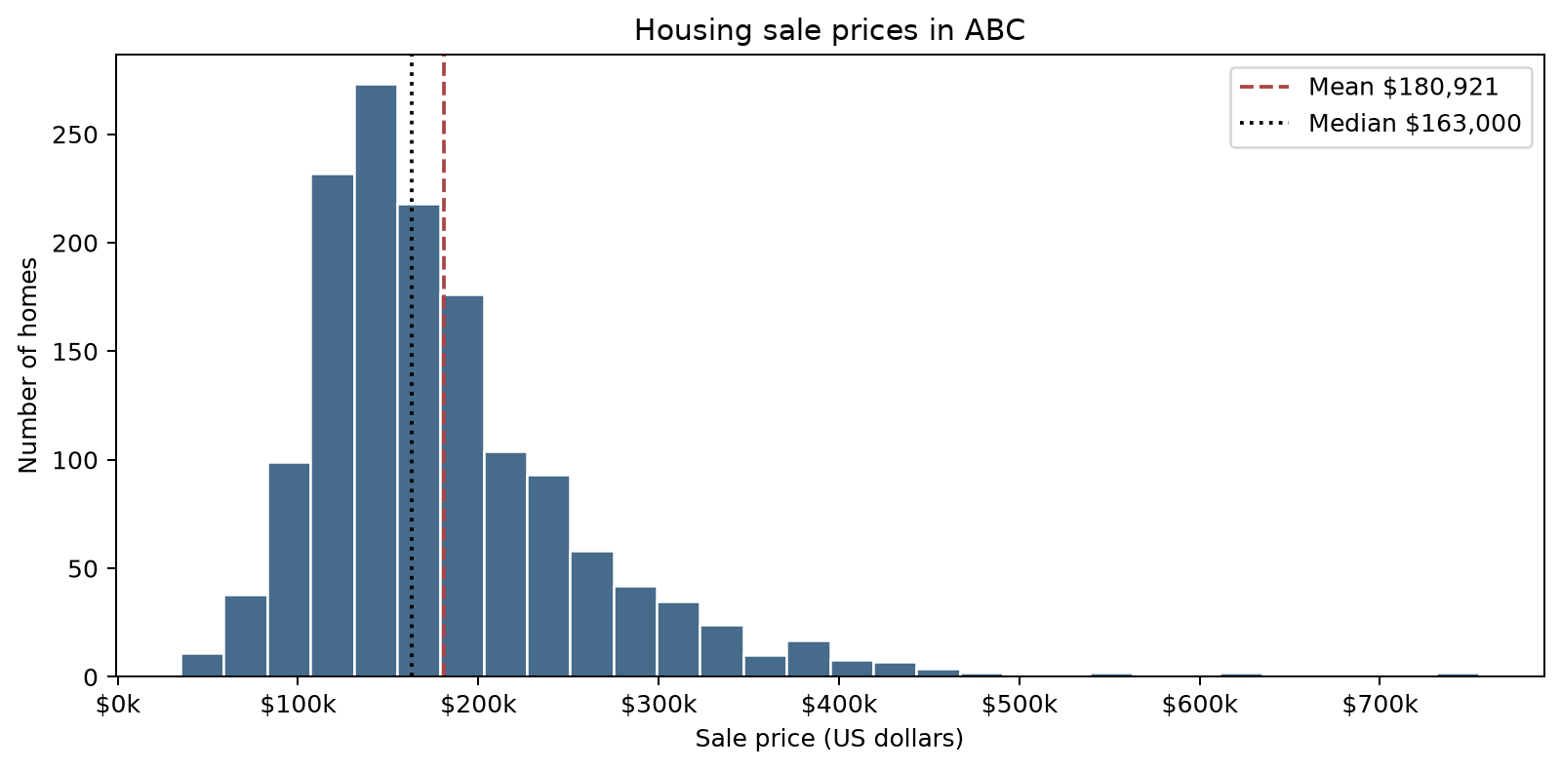
Fig. 1. Distribution of housing sale prices in ABC. Source: Author’s visualization using HousingPrices.csv; saved Colab output, Section 3. All prices are retained. The dashed and dotted lines indicate the mean and median.
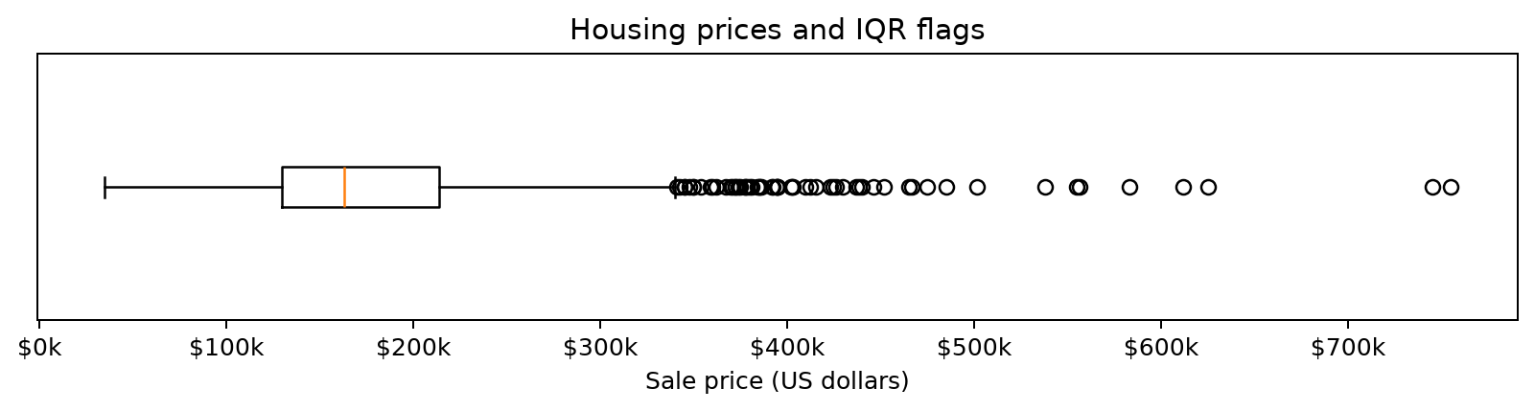
Fig. 2. Housing sale prices and IQR flags. Source: Author’s visualization using HousingPrices.csv; saved Colab output, Section 4. The 61 high-price observations are flagged for review, not automatically removed. No low-price sale falls below the lower IQR fence.

